Project Status Report

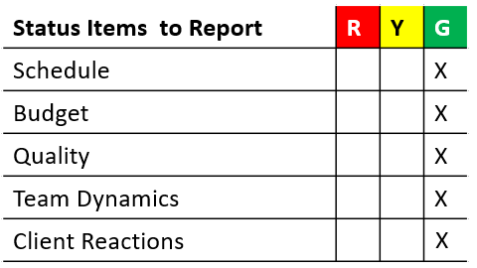

# Nikolai

**Get the mesh network communication working on the Adafruit Feathers without requiring EEPROM.**

First step was to find out how to obtain a unique identifier on the Feather M0’s.

There was the possibility of a MAC address on the Radio, LoRa serial number or the SAMD21 processor having an ID. Found a library that can extract this value and display it on serial output.



From here I hard coded the first byte in the radio sending test and assigned an ID of 1 or 2 to the two Feathers that I have for simplicity. Once the others come in, they will be assigned 3 – 7.

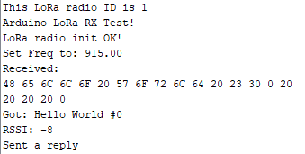

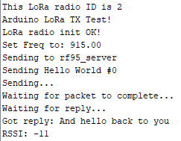

Next step is to have the Feathers go to sleep and then wake up on a timer to send a message.

This will be more difficult to debug since the serial port to the monitor gets disabled upon sleep and doesn’t get reestablished upon waking. I plan to use the built in LED to blink several times depending on whether it is sending or has received a message.

# Tyrel

* Working on interfacing simulated data into unity so that unity can depict which spot is full.
* The garage structure isn't done yet in Unity, but I figured I should make sure I can figure out how to send and receive the data how I want.
* The order for the clocks and batteries have been placed, but I haven't heard on a delivery date at this time. I am supposed to follow up with Carrie today.
* The boards should all be at the den. But again, I am following up with Carrie when I get there.

# Zane

# Joel